Social Network Analysis Based on the Marvel Universe

Course Name: | COM5506 Soc Network Anal for Commnct'n
Group Members: | YI Ru 59331587
 | MA Liming 59806782
 | MIAO Yihan 59962926
 | ZHU Ziming 59909421
 | DENG Yuxuan 59905563

April 28, 2026

Abstract
This research takes the Marvel Universe as research object, constructing a social network that characters serve as nodes and co-appearance in the same comic book or film is defined as an edge. A systematic investigation was conducted on 327 characters across four distinct eras. The results show that the Marvel character network exhibits significant small-world properties and a core-periphery structure. A small number of characters, led by Captain America, maintain cross-era hub positions. Although the proportion of female characters has increased significantly since the Bronze Age, and racial diversity has become pronounced in the Modern Era, the marginalized pattern has not been fundamentally altered.

1 Introduction
1.1 Research Background
The Marvel Universe is one of the most influential fictional worlds in contemporary popular culture, spanning comics, films, and multiple media platforms. With a large number of interconnected characters and complex storylines, it provides a rich context for studying interaction patterns within a large-scale network.
In such a narrative system, characters are not independent entities but are linked through shared appearances, collaborations, and conflicts. These relationships can be represented as a network, where nodes correspond to characters and edges represent co-occurrence or interaction. Modeling the Marvel Universe in this way allows for a systematic examination of how structural positions are distributed across characters and how interaction patterns emerge at different scales (Newman, 2010).
Social network analysis provides a suitable framework for examining these patterns (Wasserman & Faust, 1994). It enables the identification of structurally central characters, the detection of communities, and the analysis of how different attributes relate to network position. Rather than focusing solely on overall structure, this approach makes it possible to explore variation at the node level.
As one of the most commercially successful and culturally influential narrative systems, the Marvel Universe also offers a valuable case for understanding how large-scale character networks are organized and sustained over time. Analyzing its network structure can provide insights into how central characters are positioned and how different groups are interconnected, which may have implications for the design and development of similar character-driven narratives in other forms of media.
1.2 Literature Review
Alberich, Miro-Julia, and Rosselló (2002) conducted a pioneering study on the Marvel Comics character network. Based on the Marvel Chronology Project database, the study constructed a character co-occurrence network—in which two characters are connected if they appear in the same comic book. The network comprises 6,486 nodes and 168,267 edges, with an average degree of 51.88. Key findings include: (1) the network exhibits small-world properties, with an average path length of 2.63 and a diameter of only 5; (2) the existence of a giant connected component covering 99.42% of the characters, with Captain America at the network’s center; (3) the degree distribution follows a power-law, indicating that the network possesses scale-free properties.
This study demonstrates that social network analysis can be effectively applied to fictional narrative universes, providing a methodological foundation for this research. At the same time, since the study did not incorporate character attributes and was a static analysis, it inspires this research to incorporate dimensions such as gender and race into the Marvel comic book character , as well as to introduce a temporal dimension to examine the patterns of network evolution.
Richter (2016) examined the Marvel Cinematic Universe from the perspective of transmedia storytelling. Applying Henry Jenkins’ theory of transmedia storytelling to the Marvel Cinematic Universe, the study argues that Marvel’s practice of distributing storylines across films, television series, web series, short films, and comic book spin-offs constitutes an “internal transmedia” practice—where individual units, though incomplete on their own, collectively form a coherent whole.
Richter’s research aids in understanding the narrative logic and industrial context of the Marvel Cinematic Universe, providing a theoretical foundation for interpreting the results of network analysis. For example, Richter identifies characters such as Captain America as cross-platform “network hubs,” a finding that corroborates this study’s conclusion that Captain America ranks first across all centrality metrics. Furthermore, this research inspired the present study to consider the significance of character centrality from the perspective of transmedia storytelling.
1.3 Research Questions
Based on the above background and existing literature, this study aims to examine the structural characteristics of the Marvel character network and to explore how node-level attributes are associated with network position. In particular, the study investigates which characters occupy the most central positions in the network and whether structural and demographic attributes—such as gender, alignment, race, and team participation—are associated with variation in centrality measures. It also considers whether team participation influences a character’s structural role, especially in terms of connectivity and influence. Furthermore, the study explores patterns of clustering and connectivity within the network, with a particular focus on whether highly connected characters tend to function as bridges across different groups rather than remaining within tightly connected communities.
2 Methodology
The data used in this study is obtained from the Marvel network dataset in the Sample Social Network Datasets repository by Melanie Walsh, based on the Marvel Chronology Project. The dataset records co-occurrence relationships between characters, where two characters are connected if they appear in the same comic book.
The network used in this study includes 327 characters, selected based on connectivity and activity criteria: each character is connected to at least eight others and appears in at least five comic books. This filtering focuses the analysis on well-connected and frequently occurring characters.
Each character is associated with several attributes, including gender, alignment, race, and team participation. While the co-occurrence relationships are derived directly from the original dataset, these node-level attributes are compiled and organized for this study from supplementary sources. Characters are also categorized into four historical eras based on year of first appearance, following standard comic scholarship: Golden Age (1930s–1950s), Silver Age (1950s–1960s), Bronze Age (1970s–1980s), and Modern Age (1990s–present).
To analyze the network structure, several node-level metrics are used, including degree centrality, betweenness centrality, closeness centrality, eigenvector centrality, and clustering coefficient. These metrics are computed as part of this study. In addition, team_count measures the number of teams each character belongs to, allowing for the analysis of how cross-group participation relates to network position.
The basic data preprocessing and formatting are conducted using Python, primarily relying on the following libraries:
Library Name | Purpose
pandas | Data reading, cleaning, integration, and management
networkx | Network construction, centrality metric calculation (degree centrality, betweenness centrality, closeness centrality, eigenvector centrality, clustering coefficient)
matplotlib / seaborn | Data visualization (centrality distribution plots, box plots, etc.)
numpy | Numerical computation and array operations

The network is visualized using Gephi, which allows for the exploration of overall structure and the identification of patterns and clusters among characters.
For statistical analysis, SPSS is used to conduct descriptive, correlational, and regression analyses. Centrality measures—including degree, betweenness, closeness, and eigenvector centrality—are examined in relation to node-level attributes. In particular, correlation analysis is performed to explore relationships between variables such as team participation and network position. In addition, multiple linear regression analysis is conducted to assess the relative effects of gender, race, alignment, and team participation on degree centrality.
3 Results and Findings
3.1 Overall Network Structure and Temporal Evolution
The full Marvel character network has 327 nodes (characters) and 9,891 co-occurrence edges. All nodes form a single connected component, so no character is isolated. Every character connects to the wider universe through at least one co-occurrence. This shows Marvel’s cohesive narrative design. The network has moderate density. Each character has about 60 connections on average, which fits Marvel’s team-focused storytelling.
The network shows clear small-world properties. These properties make the network structurally efficient. The average path length is 1.873. Any two characters are linked by fewer than two intermediate roles on average. The maximum path length (diameter) is only 3. This supports smooth cross-story interactions across the entire universe. The clustering coefficient is 0.476. Characters form tight groups like the Avengers and the X-Men. Most neighbors of a node also connect with each other. This small-world structure comes from Marvel’s core narrative strategy. It keeps global connections through crossover events and builds local cohesion through standalone team stories. This balance lets the universe grow steadily while keeping consistent narrative logic.
We also analyzed structural changes across character debut eras. The Pre-1961 (Golden Age) group has only 16 founding characters, such as Captain America. These early characters built the core foundation of the network. The Silver Age (1961–1970) added 106 new characters. The Avengers and X-Men first appeared, forming a dual-core structure. The Bronze Age (1970–1980) added 146 characters. The network reached its largest size and most complete structure. The Modern Age (1990s–present) added 51 new characters. The network shifted to small-group dynamics. Team connections became tighter, but cross-community links grew weaker. The higher clustering coefficient in the Modern Age happens because Marvel focuses more on standalone team storylines. This strengthens internal co-occurrence but reduces cross-era and cross-team interactions.
3.1.1 Community Detection Method and Validity Verification
This study uses the Louvain community detection algorithm. It clusters characters based on co-occurrence relationships. The algorithm finds groups with dense internal connections and sparse external links. It also assigns a community label to each node.
The network modularity Q is 0.435. In social network analysis, a modularity score between 0.3 and 0.5 means a clear and stable community structure. This result means the algorithm correctly captures the real co-occurrence patterns of Marvel characters. The community division matches the actual narrative setup of the Marvel universe.
The algorithm identified 7 stable communities. Community 0 has 94 nodes, the largest group, centered on X-Men characters. Community 2 has 86 nodes, the second-largest group, centered on Avengers characters. Community 3 has 40 nodes, Community 5 has 37 nodes, and Community 4 has 32 nodes. Community 6 has 20 nodes, and Community 1 has 18 nodes, which are smaller.
Overall, the Marvel network follows a dual-core, multi-community structure. Communities 0 and 2 make up over 55% of all nodes. They are the core clusters of the network. The other five communities act as supplements around the core. Together, they form the complete Marvel character system. This dual-core structure reflects Marvel’s long-term narrative plan. The X-Men and Avengers are the two core IP lines that support the whole universe’s character system and story expansion.
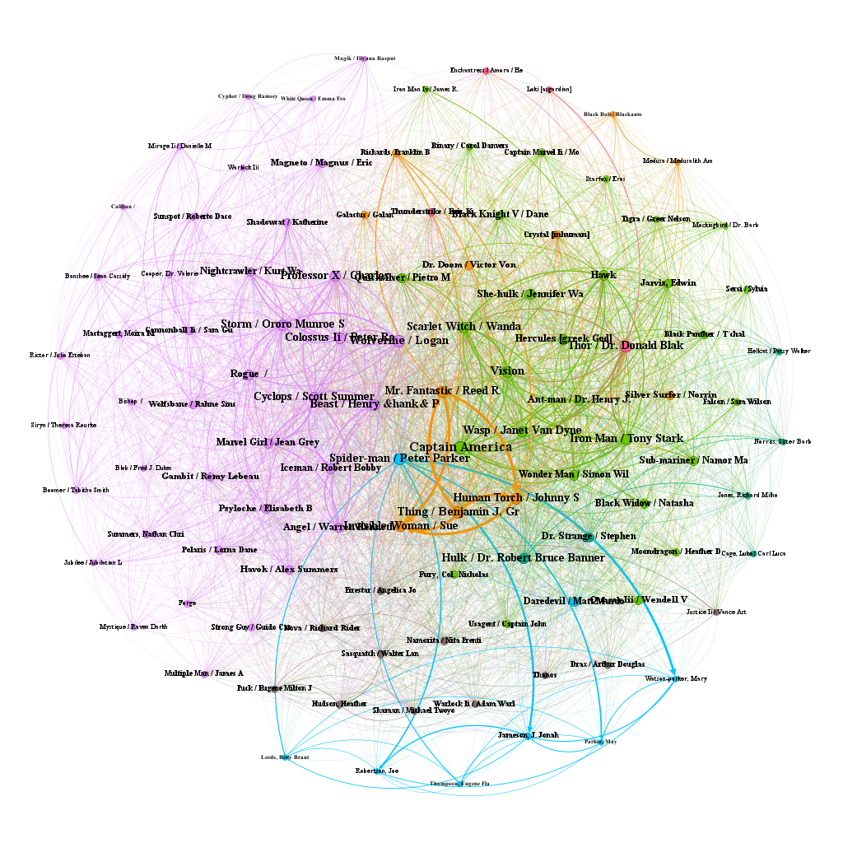
Figure 1 Community visualization.

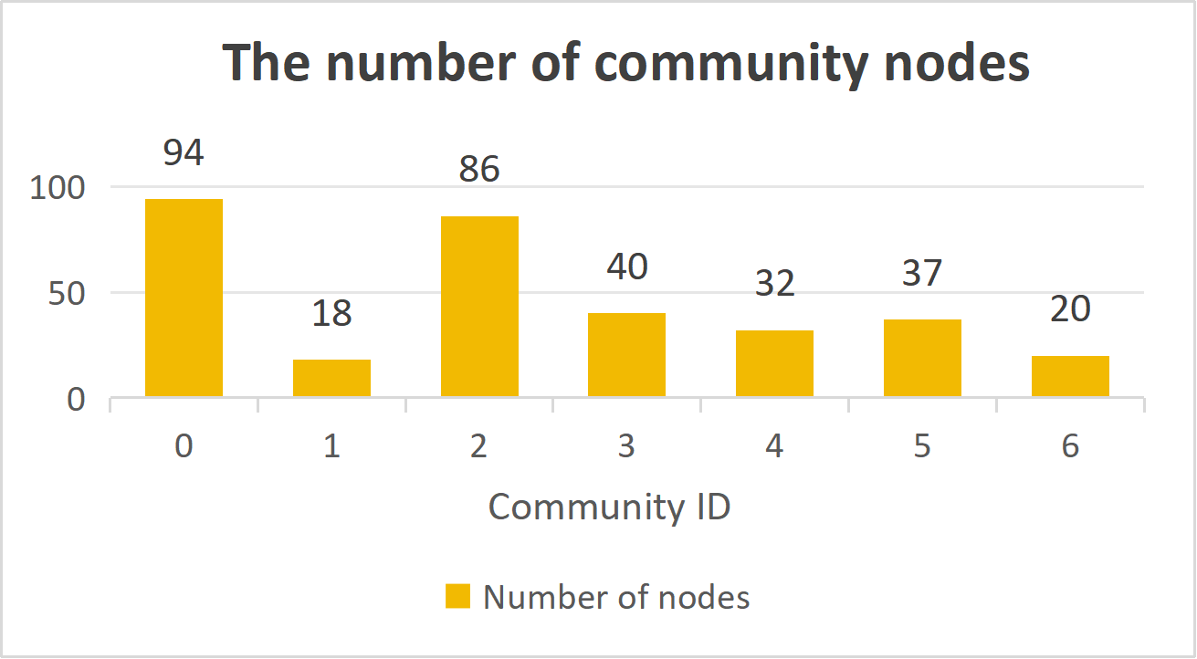
Figure 2 Community visualization.

3.1.2 Visualization of Two Core Communities
Community 0 is the X-Men-centered group with 94 nodes. It has high internal cohesion and relative IP independence. Internal interaction density is very high. Core nodes like Wolverine, Magneto, Cyclops, and Professor X form a stable core-periphery structure. Cross-community links are limited. This matches the relatively independent narrative of the X-Men series in Marvel. This structure comes from Marvel’s early focus on building the X-Men as a standalone IP. There were fewer crossover plots with other superhero teams.
Community 2 is the Avengers-centered group with 86 nodes. It has a multi-core structure and high cross-IP interaction. Captain America, Iron Man, Thor, and Black Widow serve as multiple core characters. Internal interactions are balanced and stable. This community also keeps frequent links with other communities. It is a key hub for cross-series interactions. The Avengers community is the main crossover hub because Marvel uses the Avengers as the core mainline. Many crossover events and team-up stories connect multiple side characters and sub-communities.
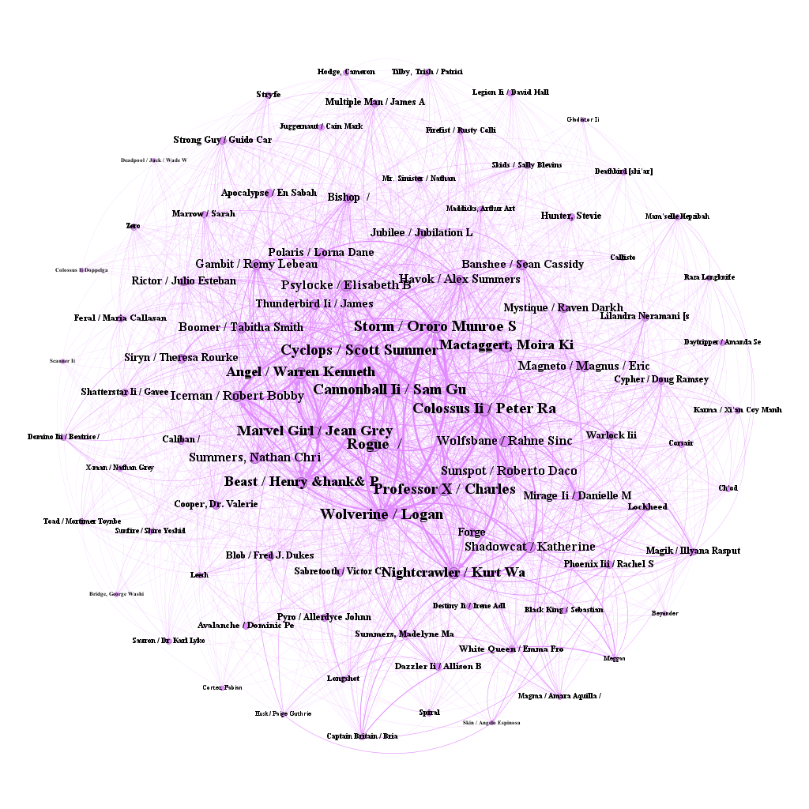
Figure 3 Community 0 Visualization (Predominantly X-Men Characters)

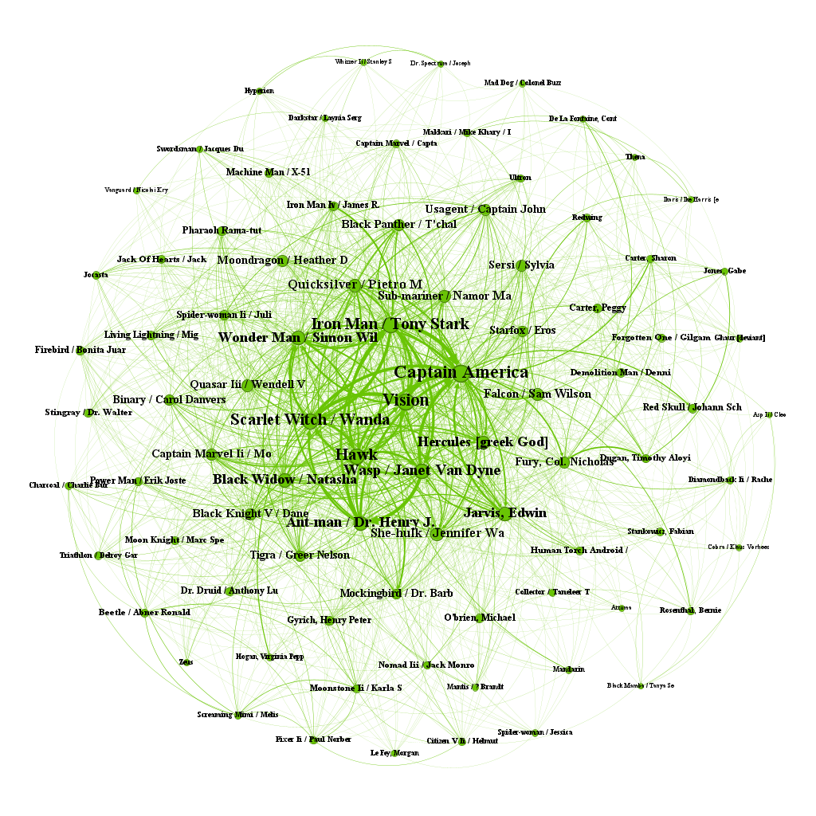
Figure 4 Community 2 Visualization (Predominantly Avengers Characters)

3.1.3 Temporal Evolution of Community Structure
This study uses a single global network for community division. Characters from each era keep the same community labels as the global network. “Community coverage” means how many global communities include characters from a given era. It is not separate community division within each era. Based on first appearance year, the evolution is as follows:
Before 1961: 16 nodes total, covering only 4 of the 7 global communities. The number of communities and nodes is small. The network structure is simple and loose. It is the initial stage of universe building.
Silver Age: 106 nodes total, covering all 7 global communities. The character system gradually improves. The network structure takes shape.
Bronze Age: 146 nodes total, still covering all 7 communities. The number of nodes reaches its peak. This is the peak of Marvel’s character expansion and the most complete stage of the community structure.
Modern Age: 51 nodes total, keeping full coverage of 7 communities. The character scale shrinks slightly. The network structure stays stable, but its core driving force weakens.
Unknown Age: 8 nodes total, belonging to 3 communities. These are supplementary characters with incomplete information. They have little effect on the overall network structure.
The community structure evolves from partial coverage to full coverage, then to stable maintenance. This path matches Marvel’s creative history. Marvel started with a small number of core characters. It gradually expanded the worldview and character groups to form a full community system. Later, it focused on developing existing communities instead of large-scale expansion.
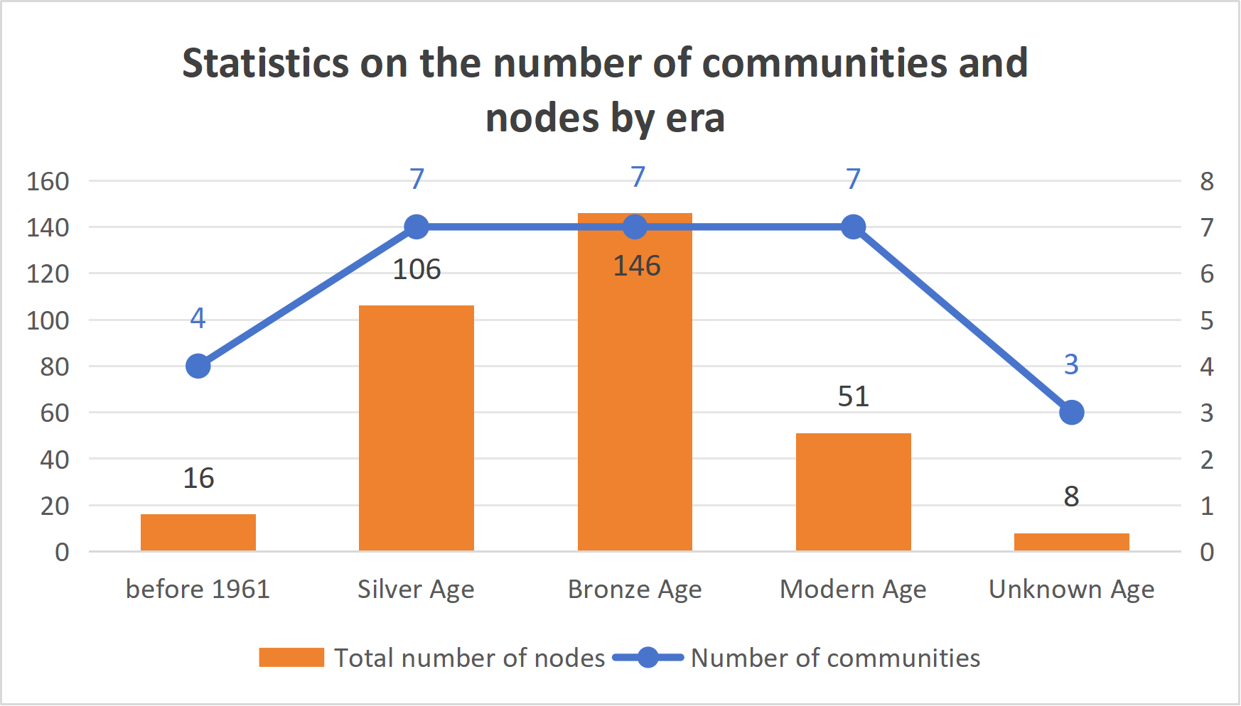
Figure 5 Temporal evolution of community structure.

3.1.4 Changes in Centrality Across Eras
To examine the evolutionary characteristics of the Marvel character interaction network across different historical periods, this study grouped characters by their debut era (before 1961, Silver Age, Bronze Age, Modern Age) and calculated the mean values of degree centrality, betweenness centrality, closeness centrality, eigenvector centrality, and clustering coefficient for each group. The results are shown in Table 1.
Table 1
Mean Centrality Measures by Era
Metric | Before 1961 | Silver Age | Bronze Age | Modern Age
Degree centrality | 0.30 | 0.23 | 0.16 | 0.12
Betweenness centrality | 0.010 | 0.0046 | 0.0016 | 0.0005
Closeness centrality | 0.60 | 0.57 | 0.54 | 0.51
Eigenvector centrality | 0.068 | 0.054 | 0.040 | 0.030
Clustering coefficient | 0.63 | 0.65 | 0.74 | 0.79

Before 1961: Early roles (appeared before 1961) were at the highest level in all central indicators. The main reason is that these characters constitute the narrative basis of the Marvel Universe: they appear early, have high cross-era participation, and are widely cited and connected by subsequent new characters. Clustering coefficient is 0.63, indicating that a closer internal connection has been formed between the early roles.
Silver Age: All central indicators are stable and relatively balanced, and the cluster coefficient is 0.65. During this period, the Marvel Universe expanded rapidly, with 106 new characters, and extensive connections were established between new and old characters. The network structure began to take shape, but there was no extreme concentration. This is a time of steady growth for the Marvel universe.
Bronze Age: The centrality index is still maintained at a high level, and the cluster coefficient rises to 0.74. During this period, the number of roles peaked (146), and the network structure was the most complete, but the average centrality had begun to decline compared to before - because the addition of more new roles diluted the centrality distribution. The number of characters reaches its peak. The network structure is the most complete.
Modern Age: Degree centrality (0.12) and eigenvector centrality (0.030) drop to their lowest levels. Clustering coefficient rises to 0.79. The main reason is that these characters tend to form a close connection within their respective teams (such as X-Men, Guardians of the Galaxy), and less interact with early core characters. This has led to the characteristics of "small groups", and the cross-era and cross-team connection is significantly weakened.3.2 Core Nodes and Central Structure.
3.2 Core Nodes and Central Structure
This study calculated the degree centrality, betweenness centrality, closeness centrality, and eigenvector centrality for all 327 characters, and identified the top three characters for each metric. The results are shown in Table 2.
Table 2
Top 3 Characters for Each Centrality Metric
Metric | 1st Place | 2nd Place | 3rd Place
Centrality | Captain America (0.79) | Wolverine (0.67) | Spider-Man (0.67)
Betweenness centrality | Captain America (0.067) | Spider-Man (0.062) | Wolverine (0.035)
Closeness centrality | Captain America (0.83) | Wolverine (0.75) | Spider-Man (0.75)
Eigenvector centrality | Captain America (0.139) | Wolverine (0.131) | The Thing (0.130)

Captain America ranks first in all four-centrality metrics, making him the network hub of the Marvel Universe. He not only has the most direct connections (highest degree centrality) but also plays the most crucial bridging role in information dissemination (highest betweenness centrality), can quickly reach any other node in the network (highest closeness centrality), and is connected to the most important nodes in the network (highest eigenvector centrality).The structural reason why Captain America can win four firsts at the same time is that he spans multiple core teams (Avengers, Aggressor, Light Note) at the same time, is active in multiple eras, and is set as the core convener of the alliance in the narrative. This makes him not only have a lot of direct connections, but also frequently acts as a bridge between different teams and roles.
Wolverine and Spider-Man rank in the top three across multiple metrics; they serve as bridges across teams and eras, establishing connections between groups such as the X-Men and the Avengers.Wolverine and Spider-Man also have cross-team and cross-era narrative character settings - Wolverine belongs to X-Men and Avengers at the same time, while Spider-Man frequently links with multiple teams - which makes them closely follow Captain America in multiple central indicators.
Further analysis of the top 10 characters by degree centrality revealed their gender, ethnicity, and core communities, as shown in Table 3. The top 10 characters by degree centrality are all male and white characters; female and non-white characters are completely absent from the core network. And the top 10 characters are concentrated within two core teams (the Avengers and the X-Men) or the Fantastic Four; these characters form the main structure of the entire network.
Table 3
Characteristics of the Top 10 Core Characters by Degree Centrality
Rank | Character | Era | Gender | Centrality | Core Team
1 | Captain America | Before 1961 | Male | 0.791 | Avengers, Invaders, Illuminati
2 | Wolverine / Logan | Bronze Age | Male | 0.675 | X-Men, Avengers, X-Force, Alpha Flight
3 | Spider-Man / Peter Parker | Silver Age | Male | 0.669 | Avengers, Fantastic Four, Future Foundation, New Warriors
4 | The Thing / Benjamin J. Gr | Before 1961 | Male | 0.656 | Fantastic Four, Avengers, Guardians of the Galaxy, Heroes for Hire
5 | Vision | Silver Age | Male | 0.653 | Avengers, West Coast Avengers, Illuminati
6 | Beast / Henry “Hank” P | Silver Age | Male | 0.629 | X-Men, Avengers, Defenders, X-Factor, Illuminati
7 | Thor / Dr. Donald Blak | Silver Age | Male | 0.629 | Avengers, Guardians of the Galaxy, Revengers, Asgardians
8 | Iron Man / Tony Stark | Silver Age | Male | 0.623 | Avengers, Illuminati, Guardians of the Galaxy
9 | Mr. Fantastic / Reed R | Before 1961 | Male | 0.607 | Fantastic Four, Illuminati, Future Foundation
10 | Cyclops / Scott Summers | Silver Age | Male | 0.604 | X-Men, X-Factor, Phoenix Force

3.3 Node Attributes and Network Position
3.3.1 Gender Analysis
To further examine the position of female characters within the Marvel interactive network, this study separately tallied the number of female characters and their specific lists in the Top 10 for each centrality metric. The results are shown in Table 4.
Table 4
Female Characters in the Top 10 of Each Centrality Metric
Metric | Number of Female Characters in the Top 10 | Specific Characters
Degree centrality | 0 | None
Betweenness centrality | 0 | None
Closeness centrality | 0 | None
Eigenvector centrality | 2 | Invisible Woman (8th), Scarlet Witch (10th)
Clustering coefficient | 3 | Volcana, Asp II, Black Mamba

First, female characters are largely absent from the most central positions in the Marvel network. In the three ways to measure “importance”—how many ties a person has, how often they connect others, and how close they are to everyone else—no woman made it into the top 10. This shows that women tend to occupy more peripheral positions in the Marvel network. They don’t have many ties, and they rarely help pass information between others.
Second, a small number of female characters, such as Invisible Woman and Scarlet Witch, appear among the top-ranking nodes in eigenvector centrality. This suggests that women can, in some cases, reach structurally prominent positions within the network. However, their high eigenvector centrality does not stem from a large number of direct connections, as their degree centrality remains relatively low. Instead, their prominence appears to be associated with their proximity to already influential nodes. For example, Invisible Woman is closely connected to Mr. Fantastic, while Scarlet Witch is linked to central figures such as Vision and Captain America.Female characters only appear in the top ten in the eigenvector centrality, but are completely absent in the degree centrality, intermediary centrality and closeness centrality. This difference shows that the importance of women's network does not come from having a large number of direct connections or acting as a bridge role, but from their close relationship with highly central nodes. This is a derivative centrality, not an autonomous centrality.In some cases, female characters enter central network positions through strong relational ties—such as romantic—to already established central figures. For instance, characters associated with core teams or relationships tend to be embedded within highly connected substructures. In this sense, the prominence of these characters reflects their embeddedness within existing high-centrality groups rather than extensive independent network reach.
Third, the “close sisterhood” among female bad-guy groups comes at a high cost—being pushed to the edge. Volcana, Asp II, and Black Mamba have very high clustering coefficients (0.96+). This means the female bad-guy group (the Serpent Society) is very tight and well-connected inside. But this inside closeness comes at the cost of being completely ignored by the rest of the network. Their group is very closed off, with limited connections to the broader network. As a result, their structural influence remains limited.High cluster coefficient does not necessarily mean high influence in the Marvel network, it appears at the same time as low centrality and low cross-group connection, but instead identifies a highly “closed-low influence” structural model.
Through descriptive comparison, this study analyzes the differences between genders across various network centrality measures. The results show that gender differences are generally limited across most centrality indicators. Male characters are slightly higher in degree centrality, closeness centrality, and eigenvector centrality, while female characters show a higher tendency in clustering coefficient; betweenness centrality also shows a relatively higher trend among male characters. However, these differences are relatively small overall and do not reflect clear structural differentiation.
In other measures, such as degree centrality, closeness centrality, eigenvector centrality, and clustering coefficient, the overall distribution patterns of male and female characters are largely similar.
These results indicate that the impact of gender on network centrality is relatively limited. The slightly higher betweenness centrality observed among male characters does not reflect structurally meaningful differences. In contrast, factors such as alignment and team participation may play a more important role in shaping network position. The top 10 are all male, which suggests that male characters are more concentrated in the most central positions; however, when considering the overall distribution, the differences between genders are not pronounced. These two findings are not contradictory, as the male dominance in the top 10 may also be influenced by other structural factors. This will be further examined in the subsequent regression analysis.
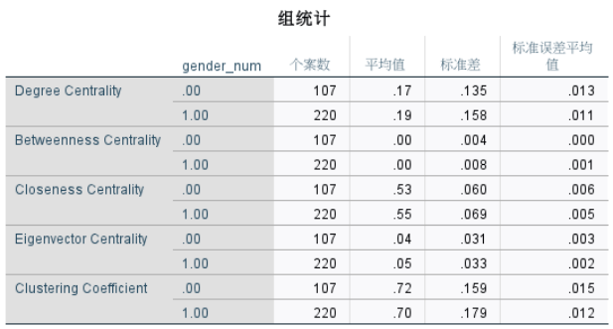
Figure 6 Gender analysis visualization.

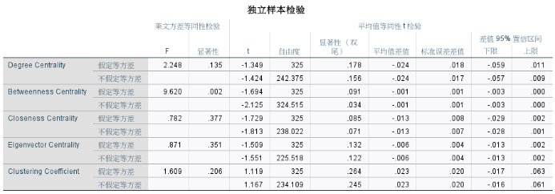
Figure 7 Gender differences statistical visualization.

3.3.2 Race Analysis
In terms of racial diversity, there has been a persistent racial structure bias in the Marvel Universe. White characters have always been in the majority in all four eras, but their proportion has gradually decreased over time. Specifically, the proportion of white characters dropped from 68.8% in the era before 1961, 75.5% in the Silver Age, and 64.4% in the Bronze Age to 54.9% in the Modern Age. Meanwhile, the number of black characters increased from 2 in the Silver Age to 10 in the Bronze Age and 7 in the Modern Age. The proportion of Asian and other characters also showed an upward trend over time.
The number of "other" characters, including aliens, mutants, and other non-human races, increased significantly in the Bronze Age (38 characters, accounting for 26.0%) and remained at a relatively high level in the Modern Age (15 characters, accounting for 29.4%), indicating that the Marvel Universe's path towards racial diversity is more about expanding the number of alien characters rather than simply reflecting the racial proportions of the real world.
Although racial diversity in the Marvel Universe has increased, the overall structure remains a core-periphery network where white characters dominate the core and minority occupy the periphery. The reason is the preferential attachment, whereby newly added nodes tend to connect to nodes that already have high degrees. In other words, newly added characters of minority are scripted to interact with the dominant white characters in the core in order to gain higher exposure. However, this also determines that they can only occupy peripheral positions attached to the core nodes, while the central status of white characters is continuously reinforced.
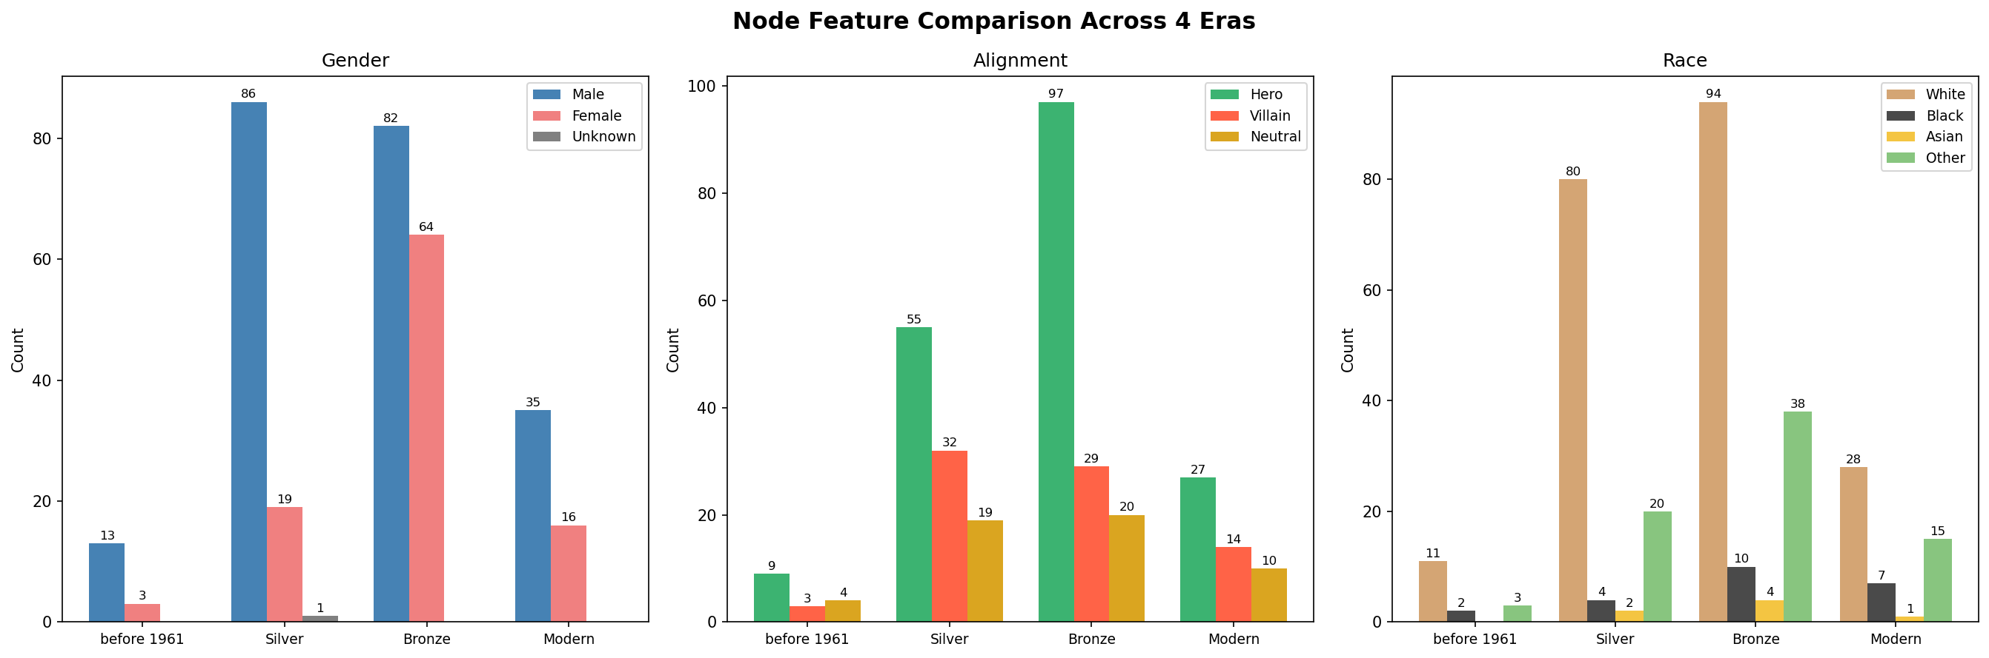
Figure 8 Race differences across the eras.

3.3.3 Alignment Analysis
Descriptive statistics indicate clear variation in centrality measures across alignment groups. Hero characters exhibit the highest levels of centrality across all indicators, with degree centrality (M = 0.22, SD = 0.173) and closeness centrality (M = 0.56, SD = 0.073) exceeding those of other groups. This indicates that hero characters occupy central positions within the network, characterized by higher connectivity and shorter average path lengths to other nodes. This reflects their role as the primary narrative core of the Marvel Universe, as they frequently participate in cross-group interactions and appear across multiple storylines.
In contrast, anti-hero characters exhibit the lowest levels of centrality, with degree centrality (M = 0.08, SD = 0.025) . This indicates that anti-hero characters occupy more peripheral positions within the network and have relatively weak structural connectivity. This may be related to their more independent or relatively isolated mode of participation in the Marvel Universe, as they tend to act alone and are less likely to form groups. It may also be associated with narrative characterization, as anti-hero characters are often portrayed as more solitary, resulting in fewer recurring connections across different groups.
Neutral (M = 0.13, SD = 0.089) and villain characters (M = 0.14, SD = 0.091) fall between these extremes, demonstrating moderate levels of centrality. In contrast, villain characters have relatively high connectivity, but are more concentrated within specific small groups rather than occupying central positions in the overall network. This is related to the fact that they often appear only within particular storylines, functioning as tools to support the development or growth of main Marvel characters, and tend to fade out after fulfilling this role. By comparison, neutral characters have a lower overall presence, possibly because their participation in the narrative is more limited or confined to specific situations, serving a role similar to background figures.

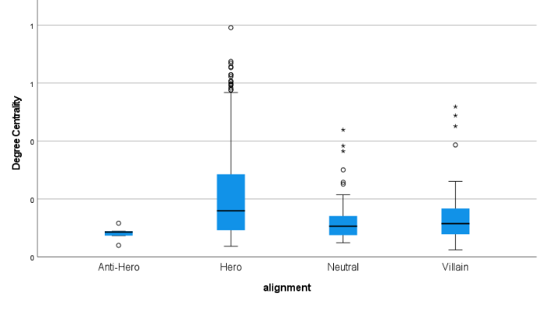
Figure 9 Alignment differences visualization.

3.3.4 Team Participation Analysis
Correlation analysis demonstrates a clear relationship between team participation and network structure. Team count is positively correlated with multiple centrality measures, including degree centrality (r = 0.417), closeness centrality (r = 0.431), and eigenvector centrality (r = 0.443). These results indicate that characters participating in a greater number of teams tend to occupy more central positions within the network. This may reflect their increased opportunities for interaction across different groups, leading to higher connectivity and broader network reach. For example, characters who are active in both core teams and other subsidiary groups are more likely to connect otherwise unconnected parts of the network, thereby enhancing their overall centrality. A representative example is Iron Man, who participates in core Avengers lineups, the Illuminati, the West Coast Avengers, and collaborations with other teams, enabling him to connect different groups within the network and occupy a more central structural position.
In contrast, team count is negatively correlated with clustering coefficient (r = -0.294), suggesting that highly connected characters are less embedded in tightly clustered local groups and instead span across different network communities. This pattern may indicate that multi-team participation is associated with a bridging role, linking otherwise separate clusters rather than reinforcing dense local structures. For instance, a character active in multiple teams may maintain connections across different groups, but those groups may not be strongly interconnected with one another, resulting in a lower clustering coefficient.
From a structural point of view, this pattern may also be related to the narrative structure. Characters involved in multiple teams usually play a connecting role between different storylines or groups, which makes them more reachable in the whole network, that is, higher in closeness centrality; their influence is also greater, that is, higher in eigenvector centrality. In contrast, characters that only stay in one team are more likely to be concentrated in small groups with close relationships. Although the local connections are stronger, their overall centrality in the network is lower.
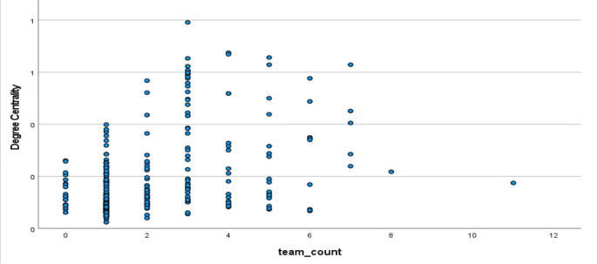
Figure 10 Team participation and network position visualization.

3.3.5 Regression Analysis
In order to further examine the importance of different attributes in the network, this study uses multiple linear regression analysis, taking degree centrality as the dependent variable, and gender, race, alignment and team participation as independent variables. The model can explain some important variations in the centrality change, so that the contribution of each predictor variable can be compared.
Among the predictors, team participation shows the strongest effect (β = .401), indicating that characters involved in a greater number of teams tend to occupy more central positions in the network. This reflects the advantages of cross-team participation, because participating in multiple groups can increase the opportunity to establish connections with other nodes, while expanding the coverage of the entire network.
Alignment also demonstrates a notable negative effect (β = –.234), suggesting that certain character types are more likely to occupy central positions than others. This pattern may be associated with the distribution of roles across the network, where some alignments are more frequently involved in central or cross-group interactions.
Race shows a relatively weak effect (β = .107), indicating a limited contribution to variation in centrality compared to structural factors.
In contrast, gender exhibits only a minimal effect on centrality, suggesting that the differences observed in descriptive analyses are more likely to be associated with other structural variables, particularly team participation.
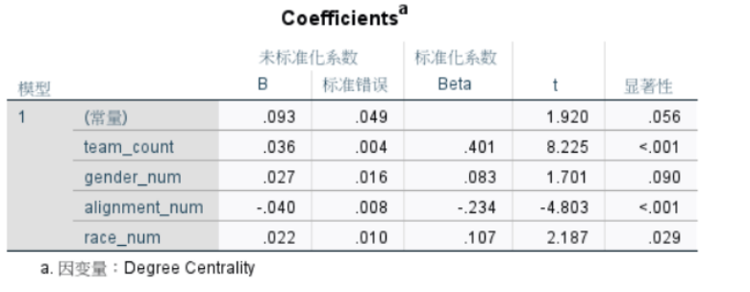
Figure 11 Regression Results Predicting Degree Centrality.

4 Conclusions
4.1 Key Findings
Based on the above analysis, this study draws the following core conclusions:
Captain America is the most central character in the Marvel Universe. He ranks first in all centrality metrics, serving as the “super-connector” with the widest network, greatest influence, and most critical bridging role within the Marvel network.
Early heroes form the “backbone” of the Marvel network. Characters introduced before 1961 rank highest overall across all centrality metrics; though few in number, they constitute the foundational network for all subsequent characters.
The modern era exhibits a “small-group” characteristic. Modern characters have the highest clustering coefficient, indicating they form tight-knit team-based connections (such as the highly interconnected X-Men), but their connections with other eras are weak, revealing a “generational gap” in the Marvel Universe.
The Marvel network exhibits a typical core-periphery distribution. A small number of superheroes (represented by Captain America, Wolverine, and Spider-Man) occupy the network’s core, while a large number of characters are positioned at the periphery.
Female characters appear to be underrepresented in central network positions. They are largely absent from the most central nodes, while the few women who enter the core tend to be embedded within existing high-influence groups. Regression analysis suggests that structural factors, particularly team participation, play a more important role than demographic attributes in shaping network centrality. While gender shows only a limited independent effect, this does not necessarily imply that gender is irrelevant. Instead, it is possible that gender differences are indirectly reflected through structural factors such as team participation, which are shaped by narrative decisions. This highlights the importance of considering both structural and narrative mechanisms when interpreting patterns of centrality in character networks.
4.2 Implications for Narrative Structure
This social network structure reflects Marvel Universe's narrative logic. As a fundamental member of the Avengers, Captain America appeared across various eras and teams. Thus, he ranks first in all centrality measures. This indicates that Marvel editors design those characters with clear central roles in mind. A few main characters connect the whole story. This makes Marvel’s world easy to expand. New roles can be added steadily without breaking the current character network.
Diversity reform has been gradual rather than radical. Although the proportion of female and minority characters has indeed increased steadily, statistical tests show that such diversity has not brought substantial changes at the network structure level. Female characters still remain on the periphery of the network and tend to gain centrality through connections with already influential nodes or established core groups. This suggests that narrative diversity remains at the level of "increasing the number of representative figures" rather than restructuring the power-relation network.
Changes in community structure reflect real-world social characteristics. The high clustering coefficient in the Modern Era is highly consistent with contemporary Marvel’s narrative style. The rise of standalone team storylines such as the X-Men and Guardians of the Galaxy has led to increasing fragmentation in the character network: connections within each team are tight, while cross-team linkages have weakened.
4.3 Limitations and Future Research
Limitations in sample selection: The dataset used in this study excludes less-connected and less frequently appearing characters. While this helps focus the analysis on active and structurally meaningful nodes, it may also bias the distribution of centrality and reduce the representativeness of peripheral characters.
Limitations in network construction: Character connections were defined based on co-appearance, which cannot distinguish the nature of interpersonal relationships or support in-depth analysis of the structural characteristics of relationships between characters.
Subjectivity in era division: The division of the four eras follows the consensus standard among Marvel fans, without statistical analysis of the debut eras of individual characters. This may affect the results of cross-era comparisons.

